Human Trafficking in Maine: Identification & Response

Training Activity Guidebook

Your role and the needs of VoTs

How are you meeting the needs of VoTs?

Who are your partners in doing so?

What are the continued conversations your organization can have to better identify and meet the needs of VoTs?

Cases

SERENA
Serena is a 32 year old woman from Sudan. When she was 20, violence between the government and the People's Liberation Movement reached her village. She fled, along with her family, to the Kakuma refugee camp.​ The family lived there for eight years, until her youngest child, a 2 year old boy, was diagnosed with a rare heart condition, along with severe asthma.​ Due to the child's health concerns, UNHCR prioritized the family for resettlement to the US.​ After waiting for a year and a half, the US cleared the family's case and the family was relocated to Portland, Maine.

MAHDI
Mahdi is a 25 year old man from Aleppo, Syria. In 2015, during the intensified air strikes, his mother, father, and two eldest children are killed in the family home. The university where he teaches Economics is also destroyed.​ Mahdi, his wife, and infant are smuggled into Turkey in the back of a freight truck, but the smugglers take all their savings which they had planned to use for traveling to Germany.​ Mahdi eventually finds work in a factory in Istanbul. The family moves into a basement room in a house and his wife gives birth to a baby.​ After an accident at the factory, Mahdi loses three fingers and suffers a back injury. As he can no longer support his family, he seeks help from ICRC who pushes his case forward for resettlement to the US with UNHCR.​ A year later, they are resettled to Portland, Maine.​

INES

Ines is a 45 year old woman from Honduras. After her husband is killed and her farm burned by gangs, she and her 12 year old daughter migrate up to Mexico, hoping to reach the United States.​
In Mexico, they lose their belongings, while riding on the top of a train. Out of desperation, they hitchhike on the road and are picked up by men saying they are "coyotes" (or smugglers). The men sexually assault Ines and her daughter and hold her until her family wires ransom money.​ They are released and give themselves up at the US border, where they are held in detention and Ines is given a monitor bracelet.​ Ines and her daughter are released to a cousin, living in Portland, Maine.

SERENA
The family gets settled into Portland with help from Catholic Charities. They also receive refugee cash assistance. Serena is unable to work, as her young son needs consistent medical attention. But her husband finds work in a grocery store. Serena and her husband speak very little English, do not read the alphabet, and do not have any reliable transportation.​ The family begins receiving TANF, and the refugee cash assistance stops. A friendly neighbor begins helping out with clothing donations and food. Soon the neighbor begins offering interpretation and transportation services, both things Serena needs.

MAHDI
While Mahdi was a high profile Economics professor in Syria, he is unable to find work in his field in Portland. He is also told that he needs additional training. The classes he needs are during the day which means he can't work and go to school. Yet, he needs to support his family. Instead of school, he gets work driving a taxi.​ Through driving, he is able to make a decent living and his family begins to settle into a new life. He hopes to start his classes the following year, once he has saved some money.​ One of his regular customers starts asking him about his life and he shares his experiences of the war, the loss of his family and livelihood, and the accident in the factory. The customer seems moved and offers to help his family.

INES

Ines and her daughter initially stay with her cousin, but when the cousin's own family arrives from Honduras, they are asked to leave.​ Ines and her daughter find a room to rent from another immigrant in the community. Ines, who does not speak English, finds work at a local seafood processing plant. Although she works long hours, usually leaving before her daughter is awake, her daughter quickly picks up English and is making friends in school. The daughter also help with money by working part time at a local clothing store. Together, they are able to send regular money back to family in Honduras.

Why might Serena, Mahdi, and Ines be vulnerable to trafficking?

__________________________________________________________________________________
__________________________________________________________________________________
__________________________________________________________________________________
__________________________________________________________________________________ __________________________________________________________________________________
__________________________________________________________________________________
__________________________________________________________________________________
__________________________________________________________________________________
__________________________________________________________________________________
__________________________________________________________________________________
__________________________________________________________________________________
__________________________________________________________________________________
__________________________________________________________________________________
__________________________________________________________________________________
__________________________________________________________________________________
__________________________________________________________________________________

What needs might this person’s trafficker be currently meeting? ​

__________________________________________________________________________________
__________________________________________________________________________________
__________________________________________________________________________________
__________________________________________________________________________________ __________________________________________________________________________________
__________________________________________________________________________________

What needs would need to be met in order for them to leave? ​

__________________________________________________________________________________
__________________________________________________________________________________
__________________________________________________________________________________
__________________________________________________________________________________ __________________________________________________________________________________
__________________________________________________________________________________

In your role, what needs could you support or what referrals could you make?

__________________________________________________________________________________
__________________________________________________________________________________
__________________________________________________________________________________
__________________________________________________________________________________ __________________________________________________________________________________
__________________________________________________________________________________

What indicators of trafficking do you detect from Ines, Mahdi, and Serena?

__________________________________________________________________________________
__________________________________________________________________________________
__________________________________________________________________________________
__________________________________________________________________________________ __________________________________________________________________________________
__________________________________________________________________________________
__________________________________________________________________________________
__________________________________________________________________________________
__________________________________________________________________________________
__________________________________________________________________________________
__________________________________________________________________________________
__________________________________________________________________________________
__________________________________________________________________________________
__________________________________________________________________________________
__________________________________________________________________________________
__________________________________________________________________________________

Identification

SERENA
After a few months, the neighbor begins demanding that Serena clean the neighbor's house. She does because she is grateful, but it is stressful when she needs to care fulltime for her child.​
Soon the neighbor also demands the family's TANIF money. The neighbor, who also has connections in the Kakuma camp, threatens to hurt Serena's extended family still living in Kakuma.

MAHDI

The customer, who is regularly accompanied by various women, says that he can help Mahdi earn more money, if Mahdi will drive the girls to different houses. The customer offers him $40 for a roundtrip.​ Mahdi accepts the deal and is excited for the money but soon Mahdi realizes that the girls are being taken to houses for sex work. ​Mahdi confronts the customer and tells him he won't do it anymore. The customer threatens his family, and tells him that the police won't believe Mahdi and that he will also be charged with sex trafficking.

INES
The woman, who they rent from, starts demanding that Ines do all the cooking and cleaning. ​Soon, the woman demands all the income earned by Ines's daughter. The daughter complies as the woman threatens to kick out the family on the street if they don't do what they say. The daughter is scared because it is winter and they don't have another place to live.​ When Ines confronts the woman, the woman makes additional threats, saying she will report Ines to ICE. The conversation escalates and the woman hits Ines in the head, sending her to the hospital for stitches.

Why might a victim/survivor not report their experience?

​
__________________________________________________________________________________
__________________________________________________________________________________
__________________________________________________________________________________
__________________________________________________________________________________
__________________________________________________________________________________
__________________________________________________________________________________
__________________________________________________________________________________

How might they respond to service providers?

__________________________________________________________________________________
__________________________________________________________________________________
__________________________________________________________________________________
__________________________________________________________________________________
__________________________________________________________________________________
__________________________________________________________________________________
__________________________________________________________________________________

Power
Ability to have access to and control resources, as well as decision-making. Can only exist in relation to other people.

Power Over​

- To have control over recourses, decision-making and to be able to impose these on somebody or a situation. Often power over is used in a negative way and associated with corruption, discrimination and abuse. When used negatively it means taking power from someone else to dominate them. ​

Power With​

- The ability to influence your own life by having the knowledge, skills, money or even just the ability to convince yourself to do or think something. We all have the power to, even though at times we cannot express it. ​

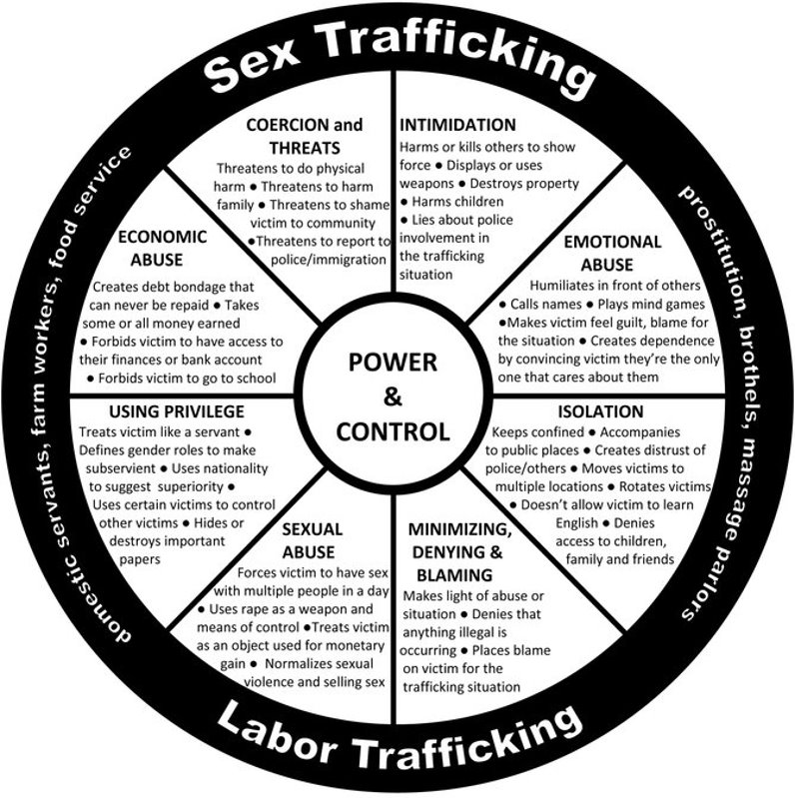

Power and Control

How might power and control play out in the lives of Serena, Mahdi, Ines?​
__________________________________________________________________________________
__________________________________________________________________________________
__________________________________________________________________________________
__________________________________________________________________________________ __________________________________________________________________________________
__________________________________________________________________________________

How might a trafficker exert power and control over them?
__________________________________________________________________________________
__________________________________________________________________________________
__________________________________________________________________________________
__________________________________________________________________________________ __________________________________________________________________________________
__________________________________________________________________________________
__________________________________________________________________________________
__________________________________________________________________________________
__________________________________________________________________________________

What form of power and control do you, your agency, or program have?

__________________________________________________________________________________
__________________________________________________________________________________
__________________________________________________________________________________
__________________________________________________________________________________ __________________________________________________________________________________
__________________________________________________________________________________
__________________________________________________________________________________
__________________________________________________________________________________
__________________________________________________________________________________
__________________________________________________________________________________
__________________________________________________________________________________
__________________________________________________________________________________
__________________________________________________________________________________
__________________________________________________________________________________
__________________________________________________________________________________
__________________________________________________________________________________

Can power over ever be used in a positive way when working with victims and survivors?

__________________________________________________________________________________
__________________________________________________________________________________
__________________________________________________________________________________
__________________________________________________________________________________ __________________________________________________________________________________
__________________________________________________________________________________
__________________________________________________________________________________
__________________________________________________________________________________
__________________________________________________________________________________
__________________________________________________________________________________
__________________________________________________________________________________
__________________________________________________________________________________
__________________________________________________________________________________
__________________________________________________________________________________
__________________________________________________________________________________
__________________________________________________________________________________

Resources

The National Human Trafficking Hotline(NHTH): Maine’s Single Point of Contact for Trafficking ​
- The toll-free hotline is available for urgent and non-urgent calls, 24/7. ​
- 200 languages are available.​
- A call to the NHTH can connect you with local Maine resources. ​
- 1-888-373-7888

Maine Sex Trafficking and Exploitation Network​
www.mainesten.org

Polaris​
www.polarisproject.org

